**RHEL7 or RHEL8 BOOT PROCESS**

**BIOS (POST AND RAMTEST)**

**MBR**

**BOOTLOADER**

**KERNEL**

**SYSTEMD (First process when we boot)**

**TARGETS**

**BOOTLOADER**

**LILO = Linux Loader used in earlier versions**

**If changes are made in the config file , you need to**

**Reload LILO**

**GRUB = GRAND UNIFIED BOOT LOADER**

**If changes are made in the config file , you need not Reload GRUB**

**Default in RHEL**

**In RHEL7 and RHEL8 /etc/grub2.cfg is the boot loader config file**

**SYSTEMD = First process when we boot the system**

**It initializes your system , in earlier versions RHEL 3,4,5,6 init process**

**In INIT all processes are run in sequence**

**In SYSTEMD all processes are run parallelly.**

**SYSTEMD IS FASTER.**

**INIT and systemd has a PID of 1**

**Runlevel = state of the OS =what services are**

**Running at that runlevel.**

**runlevel in RHEL 3,4,5,6**

**targets in RHEL8**

**MBR**

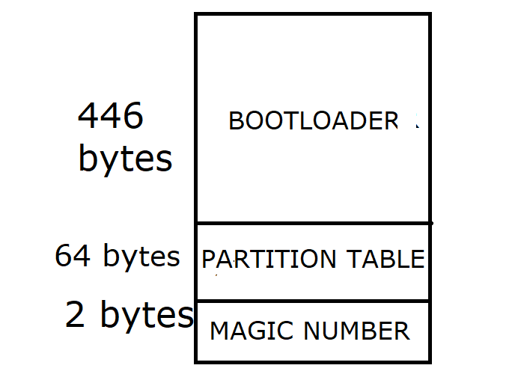

**The Magic Number serves as a validation check**

**For the MBR.**

**KERNEL**

* **Devices are detected**
* **Device drivers are loaded and initialized**
* **Root Partition is mounted read only**

**In RHEL 3,4,5 and RHEL 6 init process**

**RHEL 7,8 systemd**

|  |  |
| --- | --- |
| **Runlevel** | **Systemd Description** |
| **0** | **poweroff.target** |
| **1** | **rescue.target** |
| **2** | **multi-user.target** |
| **3** | **multi-user.target** |
| **4** | **multi-user.target** |
| **5** | **graphical.target** |
| **6** | **reboot.target** |

**Runlevel 3 or multi-user.target is full multi user mode with NFS, Networking and CLI login used in**

**Servers**

**Runlevel 5 or graphical.target is full multi user mode with NFS, Networking and GUI login used in**

**Client systems or workstations.**